

DESIGN YOUR SELF CARE TOOL

TO PROMOTE WELLBEING

SELF CARE

DESIGN YOUR SELF CARE TOOL

TO PROMOTE WELLBEING

SELF CARE

Visit [www.reconnect.nz](http://www.reconnect.nz)

Contact [team@reconnectnz.org](mailto:team@reconnectnz.org) for more information

**Self-Care Tool Name**

What do you want to make? Choose a name that reflects its purpose and makes it appealing to others.

**What is Self-Care?**

Prioritising an activity that supports your physical, mental, social, and/or spiritual wellbeing.

**Circle the area(s) of wellbeing would you like to focus on (you may choose more than one)**

- Physical Wellbeing - Mental Wellbeing - Social Wellbeing - Spiritual Wellbeing

**Purpose**

What is the main goal of your tool? What benefits will users experience by using your tool? (50-200 words)

**Target Audience**

Who is your tool designed for?

**Features (include how to use)**

Explain how your tool will work and include details about how it can promote their wellbeing (100-300 words).

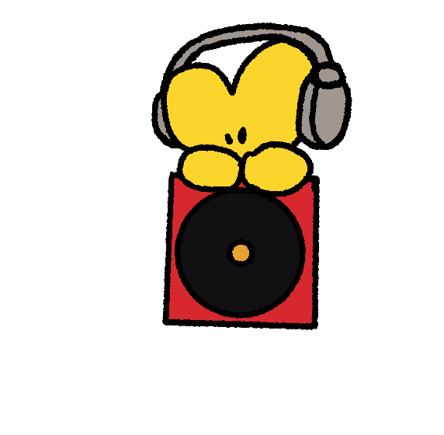

Visit [www.reconnect.nz](http://www.reconnect.nz)

Contact [team@reconnectnz.org](mailto:team@reconnectnz.org) for more information

**Additional Notes**

Share any other information or ideas that you think are important for us to know about your tool.

Or use this for extra space if you run out on other sections.

**Pitch Summary (promote your self-care tool)**

Summarise why your tool should be brought to life and how it will make a difference (20-200 words).

**Design / Visual Reference**

Describe ideas for how your tool will look and provide sketches, photos or digital designs, etc.

(Please provide references or links to the original source if it is not your own)

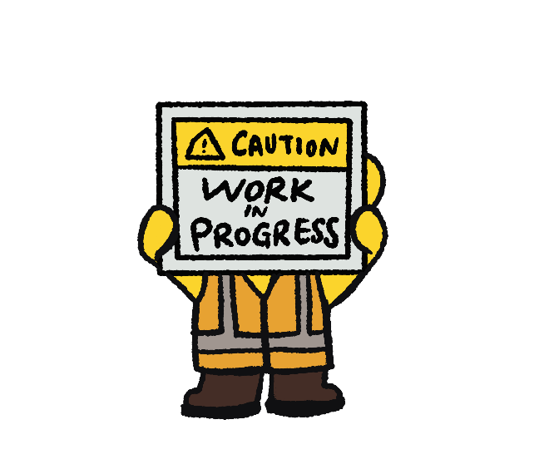

Visit [www.reconnect.nz](http://www.reconnect.nz)

Contact [team@reconnectnz.org](mailto:team@reconnectnz.org) for more information